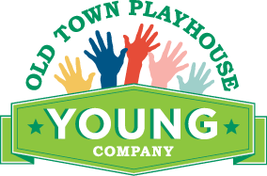
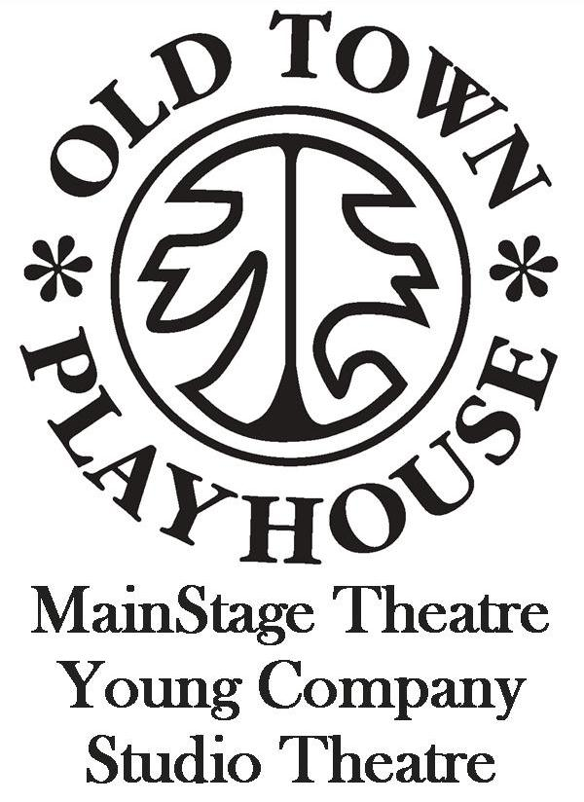
SCHOLARSHIP APPLICATION

STUDENT NAME: AGE:
GUARDIAN NAME(S):
ADDRESS:
CITY: ZIP:
PHONE: EMAIL:
PROGRAM OR CLASS FOR WHICH SCHOLARSHIP IS REQUESTED:
AMOUNT OF REQUEST: $
DOES THIS STUDENT QUALIFY FOR FREE OR REDUCED LUNCH THROUGH THEIR SCHOOL? YES / NO
PLEASE USE THE FOLLOWING SPACE TO EXPLAIN YOUR NEED FOR THE REQUEST:

PLEASE DESCRIBE THE STUDENT’S EXPERIENCE (CLASSES, CAMPS, PRODUCTIONS, ETC.):

MAIL COMPLETED FORM TO Old Town Playhouse, P.O. BOX 262, TRAVERSE CITY, MI, 49685
For OTP use:
Approved by: Scholarship Amount: $
Date: / / Date Credit Issued: / /

